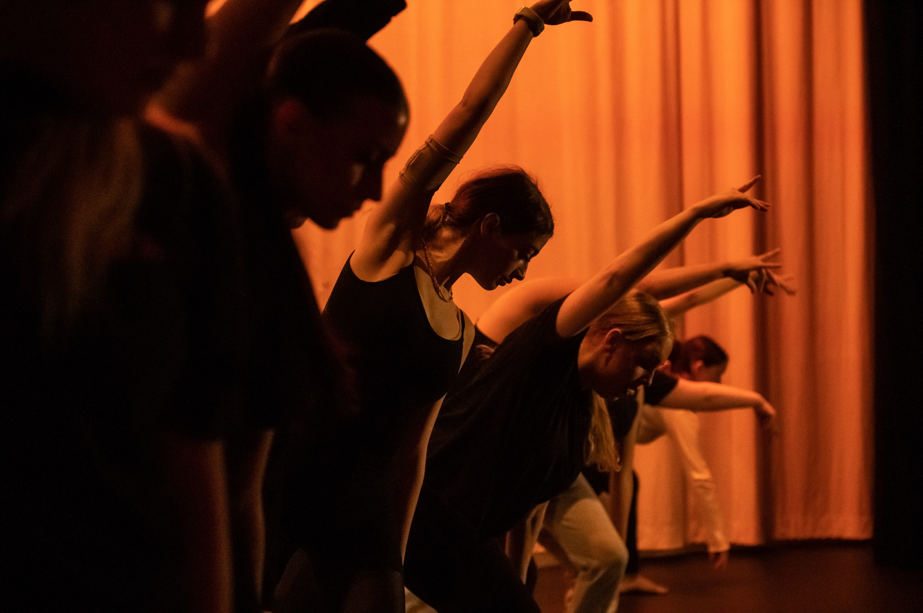

**@collyersdance presents…**

**NOTION 24**

**March 12th & 14th**

**6:30pm**

# Two evenings of exciting new work from our talented students in Collyer’s Duckering Hall

Tickets available from Collyer’s finance office cash or card

£7 Adults, £5 Concession call 01403 210822 ext 507