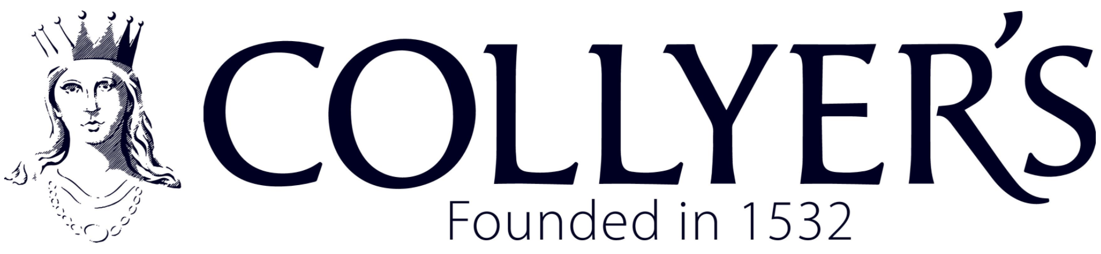
Gender Pay Gap Report - March 2024

There is a statutory requirement for employers with 250 or more employees to publish their Gender Pay Gap. This report has been prepared following government guidance, using the public sector snapshot date of 31st March 2024. The analysis includes calculating the mean, median and quartiles for each employee. The mean and median pay gap have both increased this year compared to the previous year. This is a change in trend as displayed on the below chart.

Year | Mean | Median | Lower Quartile | Lower Middle Quartile | Upper Middle Quartile | Upper Quartile
2024 | 21.63% | 39.55% | F 72.41% | F 79.31% | F 56.90% | F 45.76%
 |  |  | M 27.59% | M 20.69% | M 43.10% | M 54.24%
2023 | 16.8% | 29.5% | F 75.81% | F 72.13% | F 63.93% | F 57.38%
 |  |  | M 24.19% | M 27.87% | M 36.07% | M 42.62%
Summary of Results

As there is a change in trend it has prompted further analysis on our result. It seemed relevant to look at the mean and median results for each quartile as below to try and identify which section the pay gap falls:-
 | Lower Quartile | Lower Middle Quartile | Upper Middle Quartile | Upper Quartile
Mean | -6.57% | 18.28% | 2.39% | 7.00%
Median | 0% | 26.51% | 8.92% | 5.43%

Analysis
The College has a higher percentage of females than males in general. There are 64.81% females compared to 35.19% being males which is similar to the previous year. The two lower quartiles contain the highest percentage of women.
In comparison to the previous year the mean pay gap of 21.63% has increased by 4.83% from 16.8% in 2023. The mean gender pay gap is £6.61 per hour. Last year the mean gender pay gap was £4.75 per hour meaning an increase of £1.86 per hour.
The median pay gap of 39.55% has increased by 10.05% from 29.5% last year. The median gender pay gap is now £13.74 per hour. Last year the median gender pay gap was £9.61 per hour meaning an increase of £4.13 per hour.
Analysing by quartile has made it easier to identify where the majority of the pay gap is, which is the lower middle quartile. This quartile has a mixture of both Teaching and Support staff.
The lower quartile is in favour of females and they include Support Staff roles which predominantly have term time only positions. These roles traditionally prove attractive to females who have primary care responsibilities for children. The lowest paid position is the Trainee Cleaner which this year are 75% male. The lower middle quartile is also female dominated but contains a mixture of roles including, Teaching, Support Staff Managers, Estates and Administration roles. Proportionally there are greater female staff in this quartile with Admin/Support roles, yet very few males with the same type of role. The upper middle and upper quartile contain Heads of Subject, Directors and Senior Management roles. Employees within these quartiles reflect their qualifications, experience, or incremental increases due to long term employment. All staff are paid their salary from nationally agreed pay scales, there is one for Teaching and one for Support Staff roles.
In comparison to other local colleges Gender Pay Gap Reports it is important to note that they do not pay their own staff for cleaning and catering services, rather these are brought in from outside services.
Bonus Pay
A group of our support staff are eligible to receive a ‘performance related’ bonus payment called Support Staff Standards Payment (SSSP) under the SFCA terms and conditions of employment. Support Staff employed on a permanent or fixed term contract within one week of the start of the Spring Term will be eligible to apply for this bonus which is paid on satisfactory performance and attendance over the previous year. The annual pay award backdated to September 2023 now incorporates this bonus within the employee’s annual salary.
Mean | Median | Bonus pay by gender
8.6% | 21.5% | F 80.2%
 |  | M 19.8%
The mean bonus pay gap has decreased this year by 2.5% and the median has decreased by 6.8% compared to last year.
Closing the Gender Pay Gap at Collyer’s
The college is confident that the gender pay gap does not stem from paying men and women differently for the same or equivalent work. It is more likely the result of the roles in which men and women work within the organisation and the salaries that these roles attract.
The College is committed to maintaining equal opportunities and equal treatment for all employees. The College can demonstrate this through our Mission and Values statements, Equality and Diversity Policy and HR policies.
The College monitors applications and appointments to ensure there is no gender bias in recruitment, selection or career promotion. We report any trends in the annual Equality, Diversity, and Inclusion review. As an equal opportunities’ employer, we firmly believe in appointing the best candidate into the role regardless of their gender or any other characteristics covered by the Equality Act. This remains our intention as stated in the College’s Staff Recruitment Policy. The college has a Staff Welfare Statement which outlines the college’s commitment to family friendly arrangements.
Laura Foskett
Finance & Payroll Manager
October 2024

