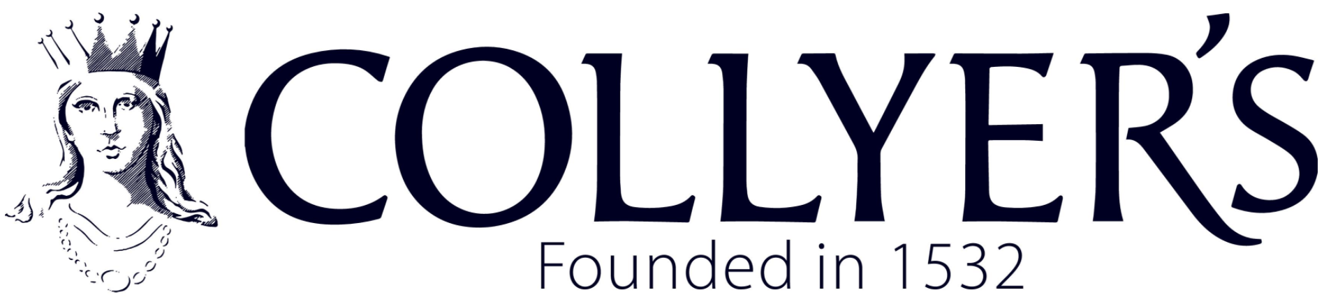
Gender Pay Gap Report - Snapshot Date: 31 March 2025

Introduction
The College of Richard Collyer is committed to equality, diversity and inclusion, and to ensuring that all staff are paid fairly for the work they undertake. The College uses nationally agreed pay frameworks and applies them consistently across the organisation.
This report sets out the College’s gender pay gap data in line with the Equality Act 2010 (Gender Pay Gap Information) Regulations 2017. It explains the gender pay gap figures published and the key factors contributing to them.
The gender pay gap shows the difference in average pay between men and women across the whole organisation. It is not the same as equal pay. Equal pay is concerned with men and women receiving the same pay for the same or equivalent work, which the College ensures through the use of nationally agreed pay scales. A gender pay gap can exist even where equal pay is in place if men and women are distributed differently across roles, grades, or levels of seniority.
Gender Pay Gap Figures
As at the snapshot date of 31 March 2025, the College’s overall gender pay gap figures were as follows:
Year | Mean | Median
2025 | 26.10% | 48.70%
2024 | 21.63% | 39.55%

The mean gender pay gap represents the difference between the average hourly pay of men and women. The median gender pay gap represents the difference between the hourly pay of the middle male employee and the middle female employee when pay rates are ranked from lowest to highest.
The significantly higher median gender pay gap indicates that women are more concentrated in lower-paid roles, while a smaller proportion of women occupy the highest-paid positions. As a result, the ‘middle’ female employee earns substantially less than the ‘middle’ male employee, even where pay scales are applied consistently and fairly.
Gender Distribution by Pay Quartile
To better understand how the overall gender pay gap arises, pay has been divided into four equal-sized quartiles based on hourly pay rates. The proportion of men and women in each quartile is shown below.

2025 Pay Quartile | 2025 Collyer’s % Female | 2025 Collyer’s % Male | 2024 Collyer’s % Female | 2024 Collyer’s % Male
Lower Quartile | 81.36% | 18.64% | 72.41% | 27.59%
Lower Middle Quartile | 79.66% | 20.34% | 79.31% | 20.69%
Upper Middle Quartile | 52.54% | 47.46% | 56.90% | 43.10%
Upper Quartile | 54.24% | 45.76% | 45.76% | 54.24%

These figures show that women are disproportionately represented in the lower-paid quartiles. This has a significant impact on the overall gender pay gap. The upper quartiles are more balanced. Below shows a comparison of Collyer’s results with the national statistics.
2025 Pay Quartile | 2025 Collyer’s % Female | 2025 Collyer’s % Male | National Statistics for Education | National Statistics for Education
Lower Quartile | 81.36% | 18.64% | 63.2% | 36.8%
Lower Middle Quartile | 79.66% | 20.34% | 62.3% | 37.7%
Upper Middle Quartile | 52.54% | 47.46% | 58.4% | 41.6%
Upper Quartile | 54.24% | 45.76% | 54.7% | 45.3%

Pay Differences Within Quartiles
The following table shows the gender pay gap calculated within each pay quartile. Negative figures indicate that women earn slightly more than men within that quartile.
Pay Quartile | Mean Pay Gap | Median Pay Gap
Lower Quartile | -1.39% | 0.00%
Lower Middle Quartile | 10.83% | 11.67%
Upper Middle Quartile | -0.09% | 0.00%
Upper Quartile | 6.30% | 2.38%

These figures indicate that pay differences within quartiles are generally small, reinforcing that the College applies pay frameworks consistently and that the overall gender pay gap is not driven by unequal pay for the same work.

Analysis
The data does not indicate systemic unequal pay for the same or equivalent roles. The data does not indicate systemic unequal pay for the same or equivalent roles. It is primarily driven by the female dominance in the lower and lower middle quartiles due to women being more likely to work in part-time, lower-paid, support positions.
Workforce Composition
The College workforce is predominantly female, with 66.95% women and 33.05% men, which is consistent with the previous year and reflective of the wider further education sector. While this overall gender balance does not in itself create a gender pay gap, it influences pay distribution where women are more likely to be employed in lower-paid and part-time roles.
Bonus Pay
There is no separate bonus pay data to report for gender pay gap purposes.
I confirm that the gender pay gap information contained in this report is accurate and has been calculated in accordance with the Equality Act 2010 (Gender Pay Gap Information) Regulations 2017.
Chief Financial & Operating Officer
March 2026

