Accessing Collyer’s
Welcome to Collyer’s!
Before you start, make sure you have:
- ✅ An email from Admissions (with your login info)
- ✅ Your mobile phone 📱
- Download Microsoft Authenticator and Microsoft SharePoint app

🔒 Step 1: Setting Up Extra Security
- 📱 Visit https://aka.ms/mfasetup
- Sign in with your Collyer’s email address and password as shown in your Admissions email. EG 26ThermDR456@collyers.ac.uk
- Click Next then Next
- Select Pair your account to the app
- It will send you a 2 digit number, type this into your Authenticator
- Done! You’re secured.

🧭 Step 3: Finding the Student CommonRoom
Open your SharePoint app
- Log on with your Collyers email address and password
- Scroll to Featured Links
- Open Welcome to Collyers or Student CommonRoom then scroll the picture Welcome to Collyers
- 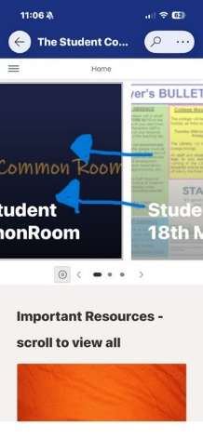

🎬 Step 4: Welcome to Collyers
- Watch videos 🎥
- Read key info 📖

Then to check out MyProgress go to: www.collyers.ac.uk/my-collyers and scroll to MyProgress. You will need to log on again with your Collyers credentials

🆘 Need Help?
- 💻 Still stuck? Email ITSupport@collyers.ac.uk
- 📍 On Welcome Day, our friendly IT team will be in:
  - The Library
  - Or in R006 just before the Shelley building
Pop in and say hi – we’re happy to help!

